|  |
| --- |
| Photo displaying partial image of two pie charts on a canvas-textured page |
| Excel and Tableau  Assessment 1 Data Visualisation |
| |  |  |  | | --- | --- | --- | | Nadezhda Ivanova | 2/1/24 | Data Technician Bootcamp | |

**Table of Contents**

# **First Task**3

POLICIES AND PROCEDURES3

# **Second Task**5

EXCEL5

1. Set a password to protect the workbook 5
2. Highlight the column C and change the data to display in British Pound symbol 7
3. Turn the GDP sheet into a table 8
4. Filter the table to display only the information for 2019 9
5. Create a chart that will only display the following data ‘Rank, Country and GDP - per capita (PPP)’10
6. Using your creative skills edit the chart 11
7. Move the chart to a new sheet tab and label with a suitable name 11
8. Create a sort for the top 20 highest ranking counties 12
9. Create a new Bar chart to display the 20 highest ranking countries from your sort and then move the chart to be underneath the table 13
10. Colour the background by highlighting the area underneath the table. Find the add a fill colour icon and select a colour 15

# **Third Task**16

TABLEAU16

1. Import data 16
2. Set relationships 16
3. Check data types 17
4. Build charts 18
5. Null values19
6. Build your dashboard 20

# **First Task**

## **POLICIES AND PROCEDURES**

*When working with data, it is crucial to adhere to various policies to ensure ethical, legal, and secure handling of information. As a data analyst, being aware of and following these policies is essential for maintaining trust, protecting privacy, and complying with regulations. Here are some key data-related policies and the reasons for adhering to them:*

1. **Data Privacy Policy:**

* What: Specifies how personal information is collected, processed, stored, and shared.
* Why: Protects individuals' privacy rights, ensures responsible handling of sensitive data, and helps organisations comply with privacy laws (e.g., GDPR, Data Protection Act 2018).

1. **Data Security Policy:**

* What: Outlines measures to safeguard data from unauthorised access, disclosure, alteration, or destruction.
* Why: Protects against data breaches, theft, and unauthorised use, helping maintain the confidentiality and integrity of information.

1. **Data Retention Policy:**

* What: Defines the duration for which data is stored and the conditions under which it should be deleted.
* Why: Reduces the risk of holding onto unnecessary information, ensures compliance with legal requirements, and minimises storage costs.

1. **Data Governance Policy:**

* What: Establishes roles, responsibilities, and processes for managing and controlling data throughout its lifecycle.
* Why: Enhances data quality, ensures consistency, and facilitates better decision-making by maintaining a standardised and organised approach to data management.

1. **Ethical Data Use Policy:**

* What: Guides the ethical use of data, addressing issues such as bias, fairness, and transparency.
* Why: Promotes responsible and fair data practices, helping prevent discrimination and ensuring that analytics results are unbiased and trustworthy.

1. **Compliance with Regulatory Policies:**

* What: Ensures adherence to industry-specific regulations and standards (e.g., Health and Social Care Act 2012 in healthcare, Financial Conduct Authority (FCA) in finance).
* Why: Avoids legal consequences, fines, and reputational damage associated with non-compliance.

1. **Data Quality Policy:**

* What: Defines standards for data accuracy, completeness, and reliability.
* Why: Improves the reliability of analytical outcomes, supports informed decision-making, and enhances the overall effectiveness of data-driven processes.

1. **Access Control Policy:**

* What: Specifies who has access to what data and under what conditions.
* Why: Prevents unauthorised access, protects sensitive information, and ensures that only authorised personnel can view or manipulate certain datasets.

1. **Data Transparency and Communication Policy:**

* What: Encourages clear communication about data practices and ensures transparency in reporting methodologies.
* Why: Builds trust with stakeholders, enhances accountability, and facilitates effective collaboration among team members.

*As a data analyst, understanding and adhering to these policies are crucial for maintaining the integrity of our work, protecting the rights of individuals, and ensuring that data is used responsibly and ethically. It also helps organisations build a positive reputation and avoid legal and financial risks associated with data mishandling.*

# **Second Task**

## **EXCEL**

1. Set a password to protect the workbook.

*Step 1:* Go to “File” tab

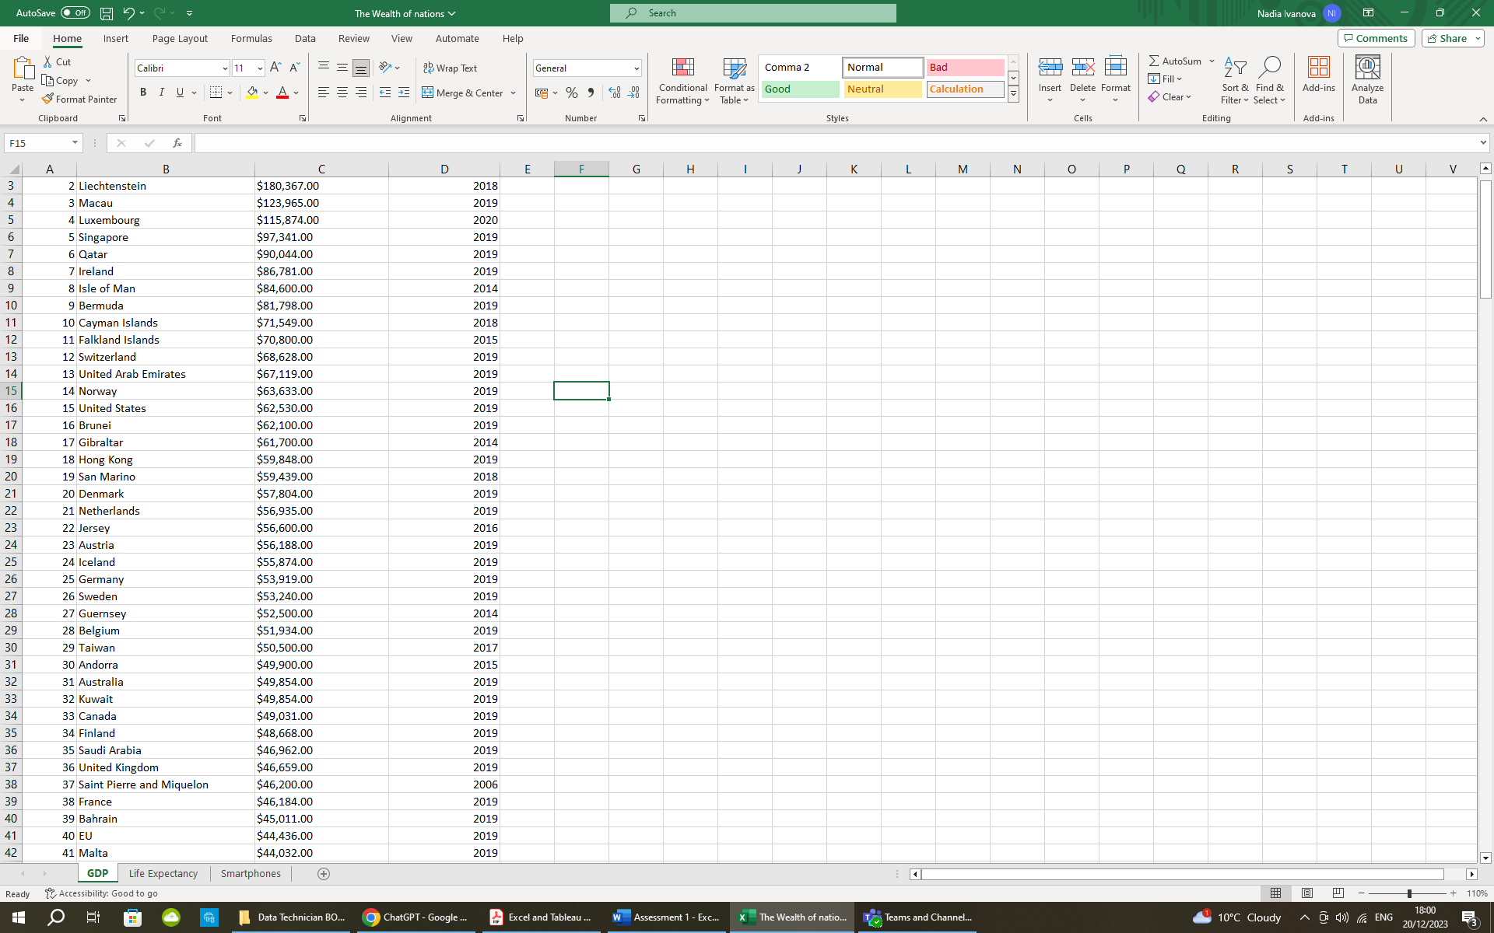

*Step 2:* Choose option “Save/Save as”

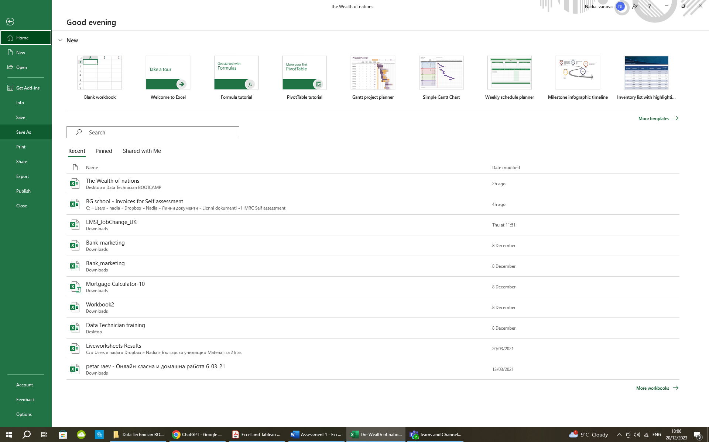

*Step 3&4:* Choose “More options…” as shown by the 1st pointer and in the newly opened window find “Tools” tab and select “General options” from the drop-down menu (2nd pointer)

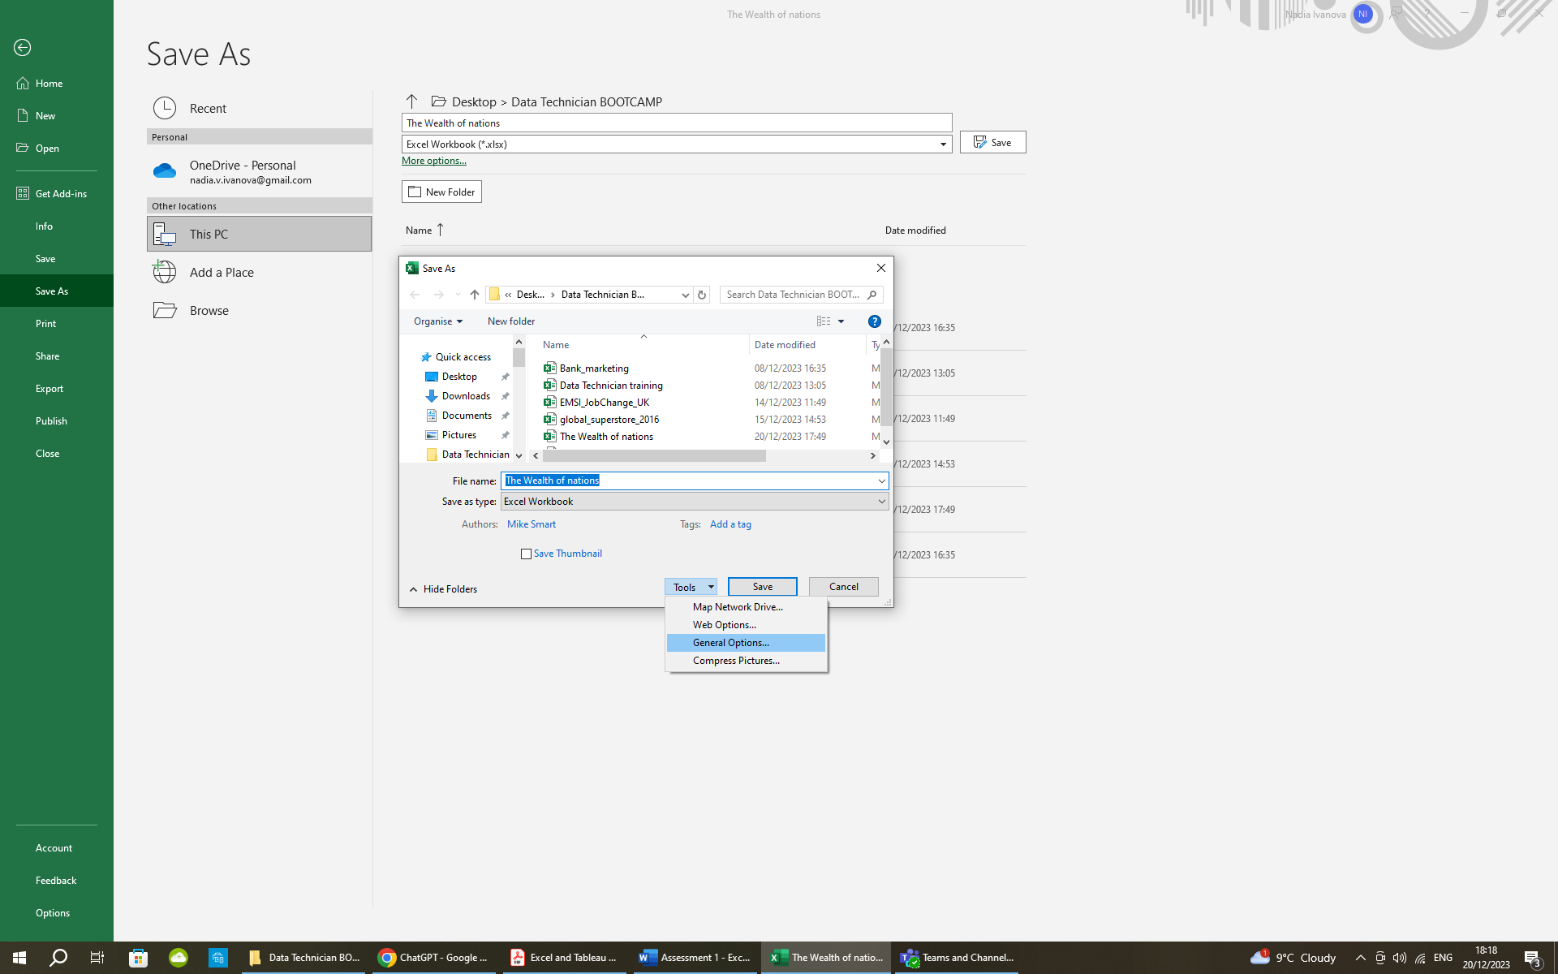

2

1 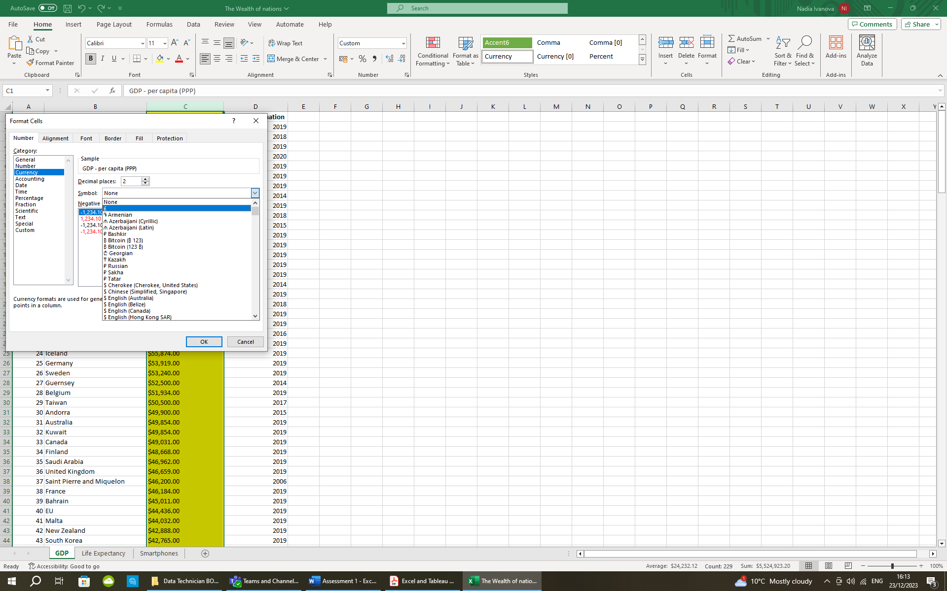

*Step 5:* In the opened window “General options” create a Password to open and, if needed, Password to modify the document. Select “Always create backup” and/or “Read-only recommended” if required and click “OK” when done.

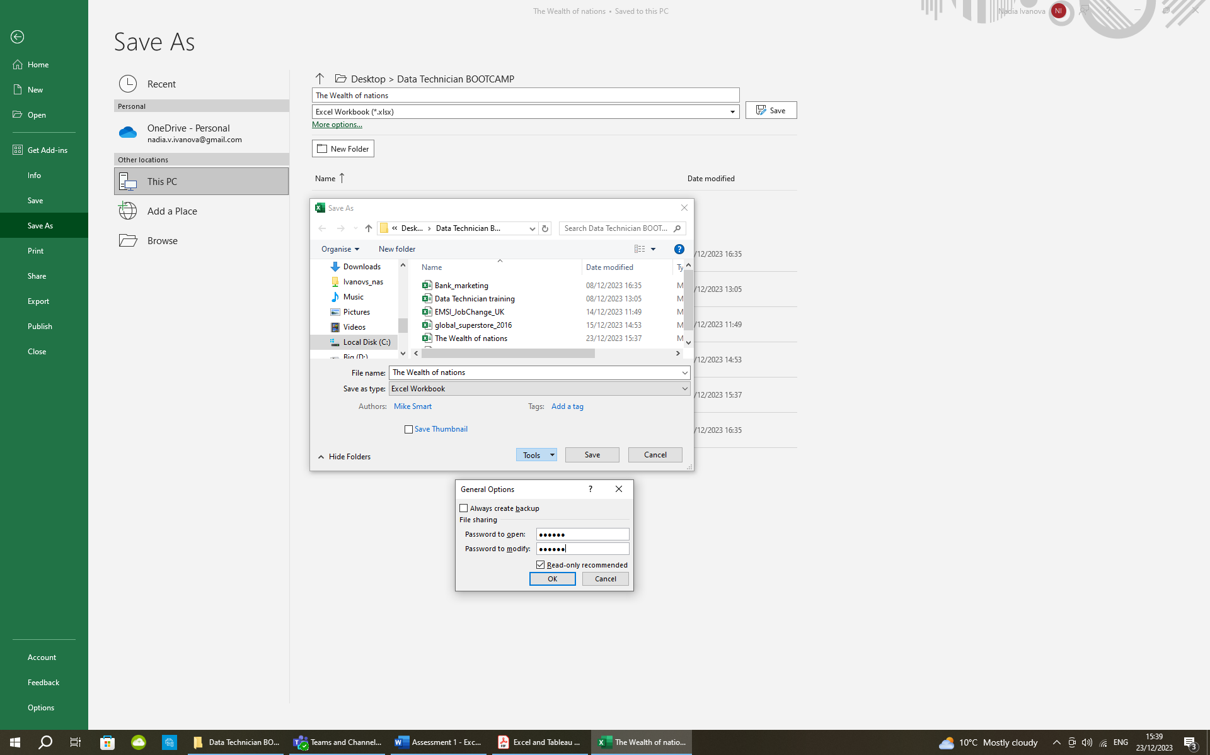

1. Highlight column C and change the data to display in British Pound symbol

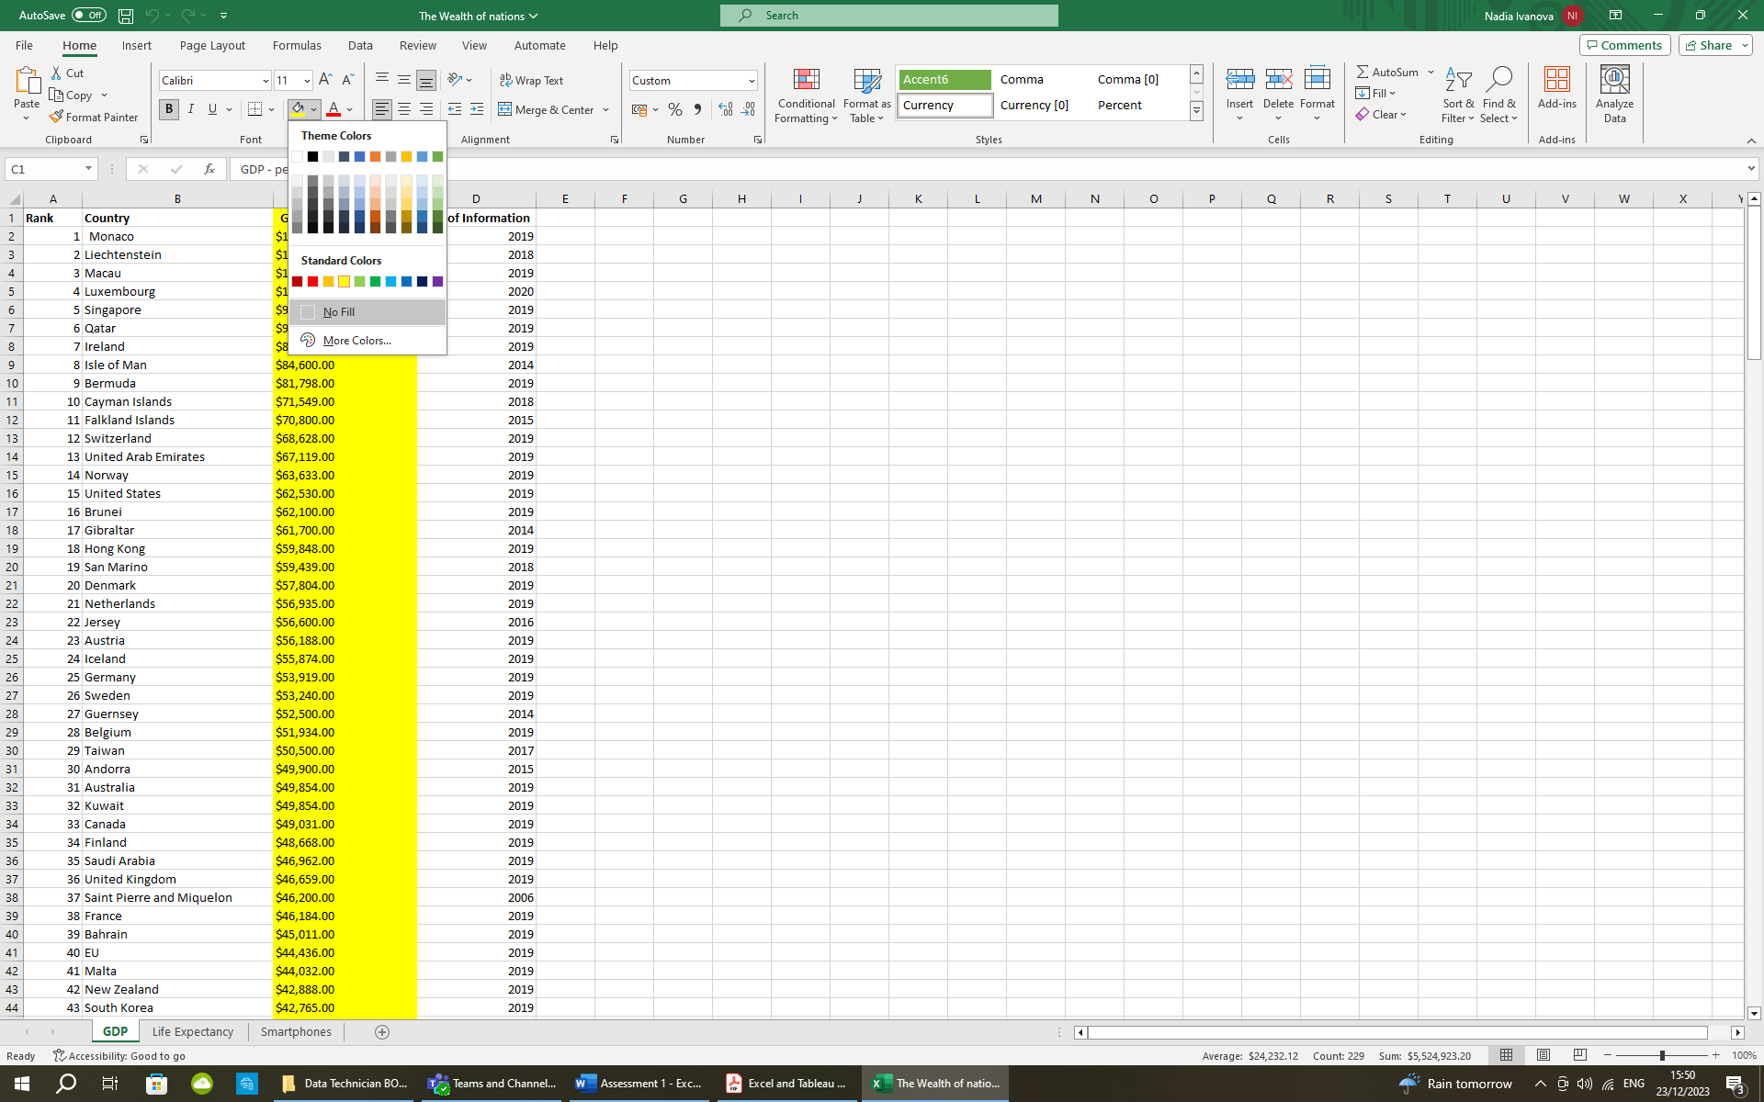*Step 1:* Select column C and from the “Fill colour” option under the Home tab choose a preferred colour to highlight the column.

*Step 2:* In order to change the currency to British Pound symbol select the column or the numbers for the change and find the “Number format” field under the Home tab, where the choice from the drop-down menu must be “Currency” (Pointer 1). If the symbol doesn’t change to British pound symbol automatically, then you need to change it from the “More Number Formats…” option at the bottom of the same drop-down menu (Pointer 2).

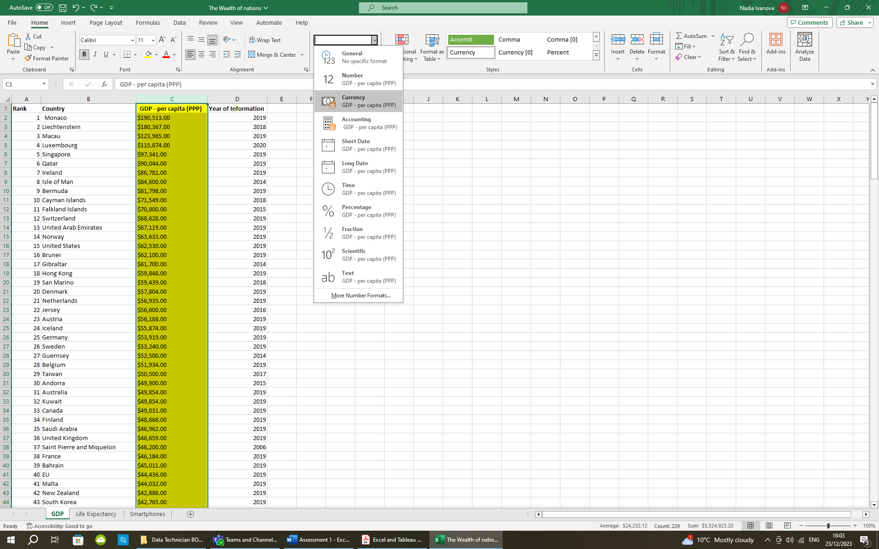

2

1 

*Step 3:* After clicking the “More Number Formats…” you will see a “Format Cells” window, where under the “Number” tab you choose “Currency” category. Find

the required symbol from the drop-down menu in the “Symbol” field and click OK when done.



1. Turn the GDP sheet into a table.

*Step 1:* Select the cells to go into the table, then find and click on the icon “Format as Table” under the Home tab (Pointer 1). Choose the style for your table and click on it (Pointer 2).

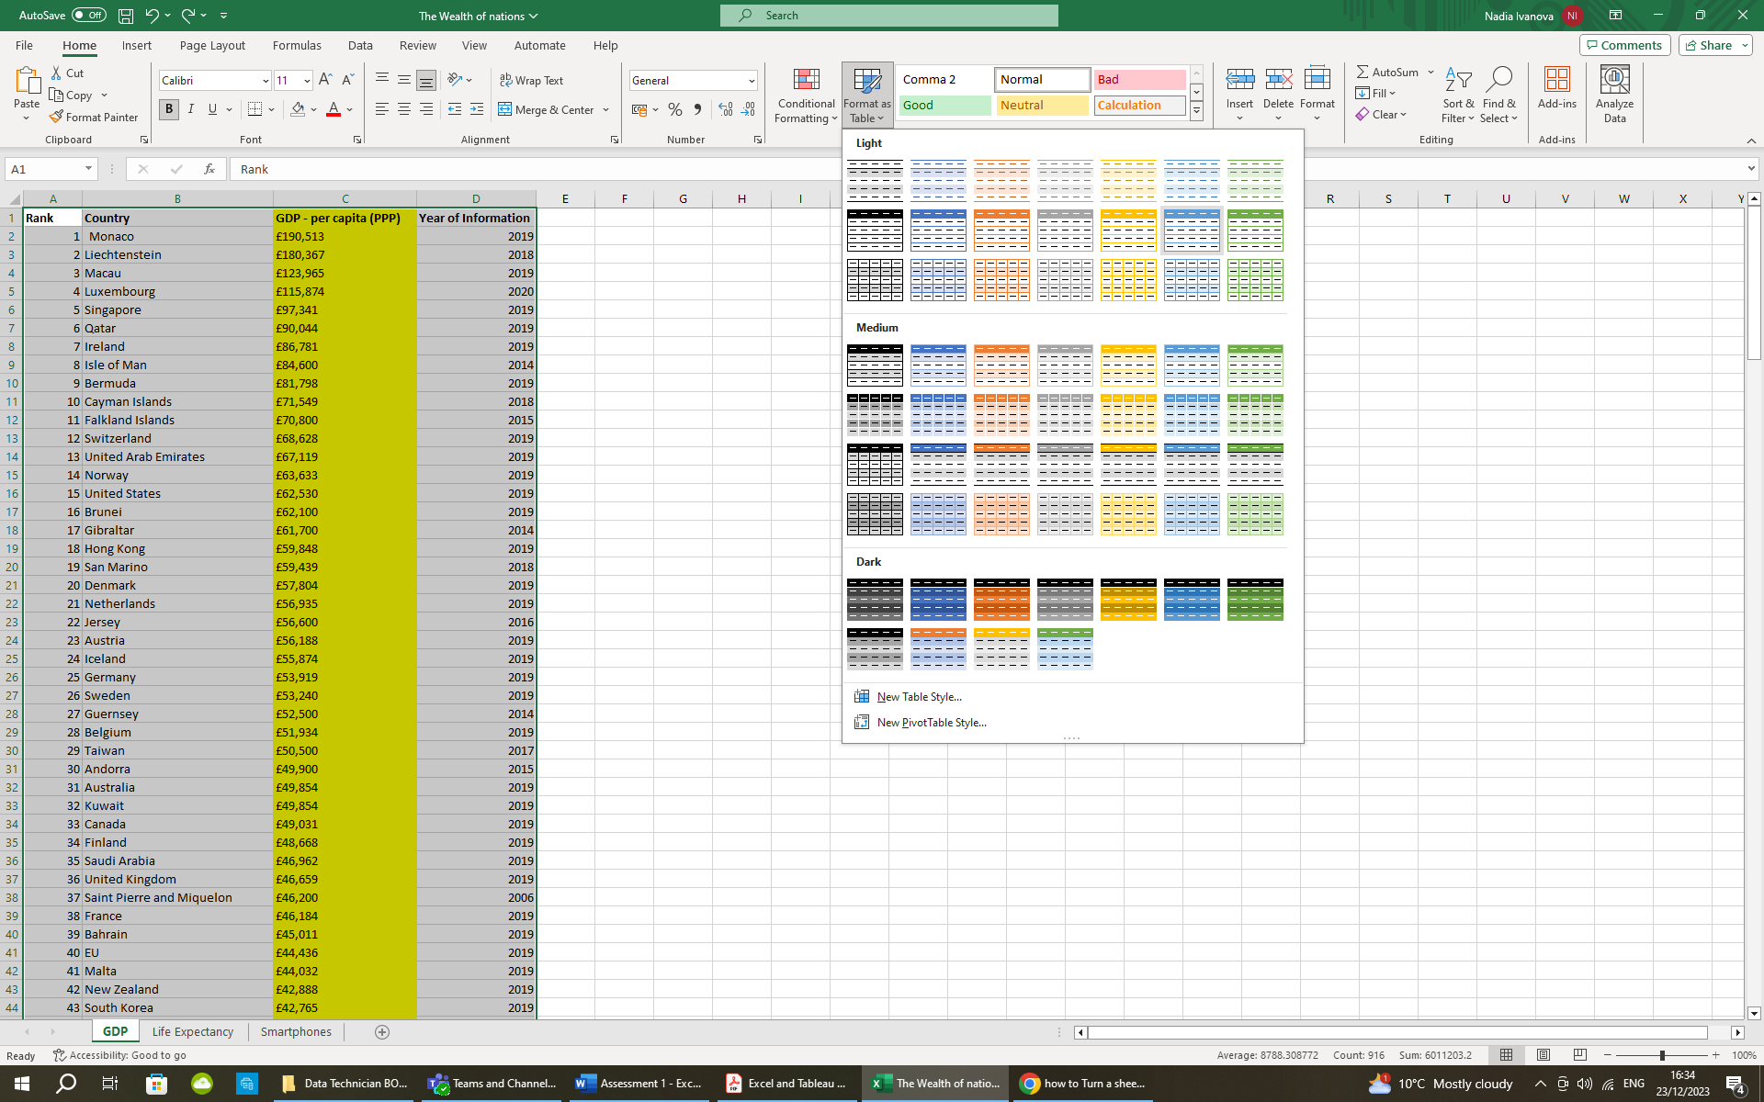

2

1 

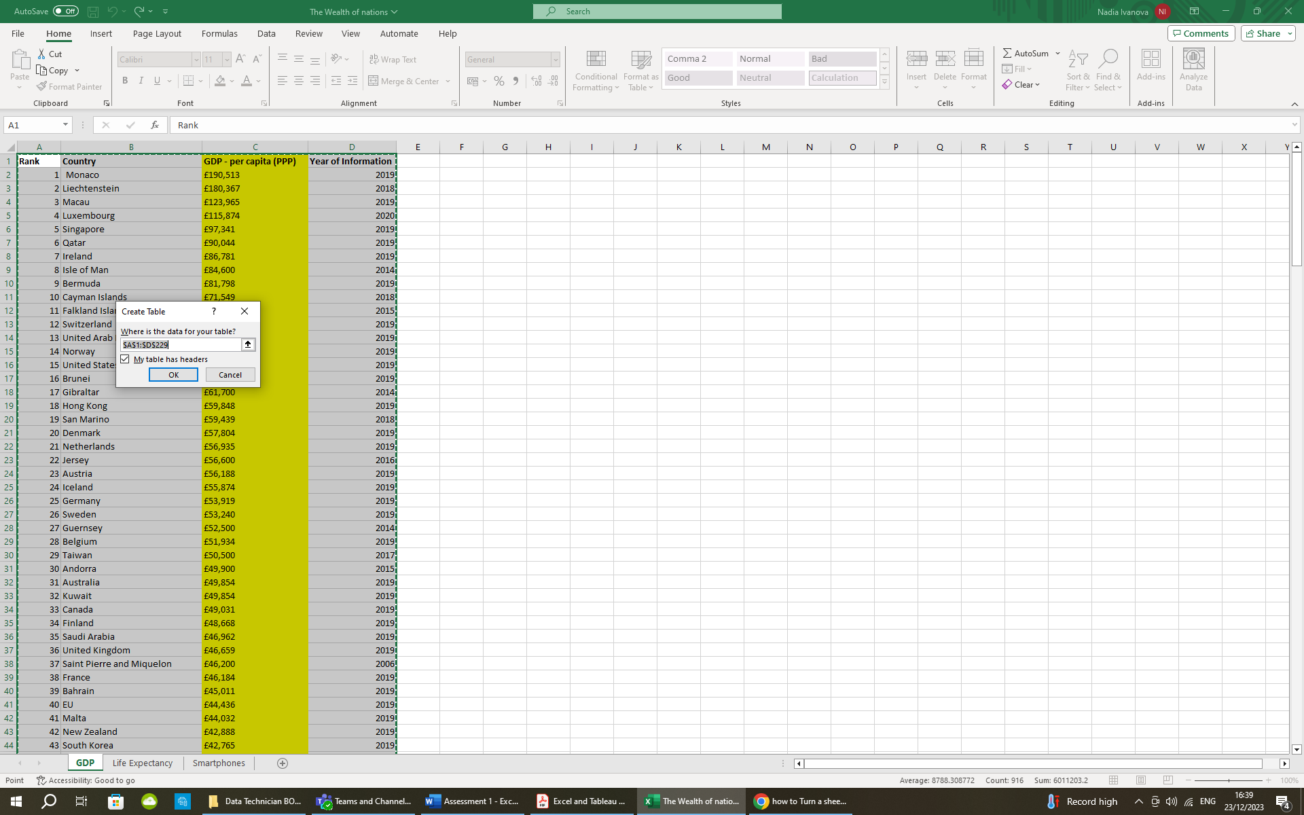*Step 2:* In the opened “Create table” dialog box set or adjust your cells range and mark “My table has headers”. Select OK when done. This will allow you to filter the data easier, as shown in the next section.

1. Filter the table to display only the information for 2019

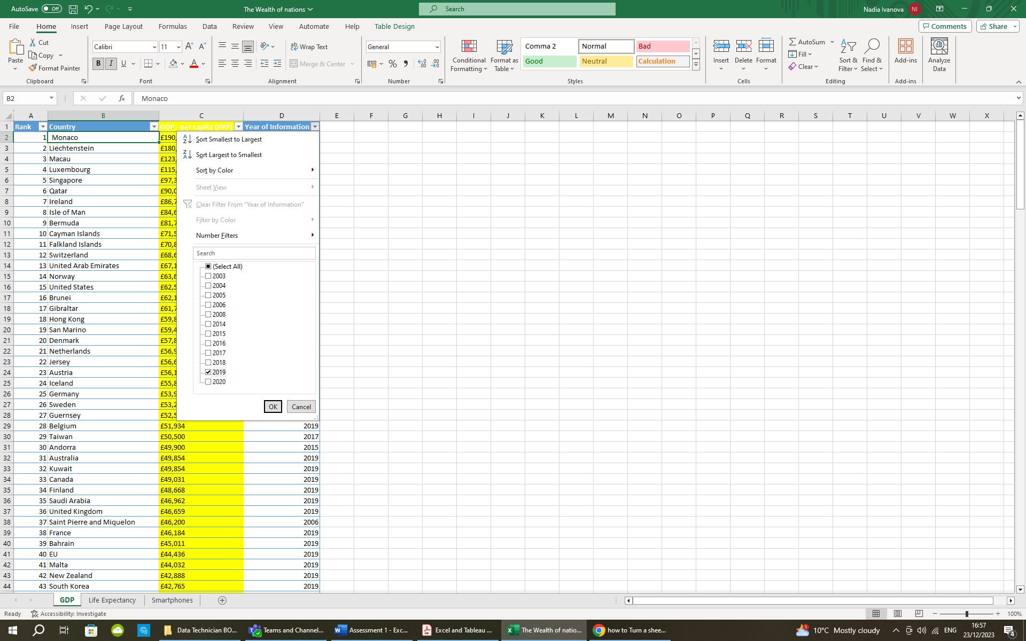*Step 1:* From the drop-down menu under “Year of Information” table tab you will see all available years.

*Step 2:* All available years will be marked. The easiest way to select only the 2019 is to click on “Select all” to unselect and then to mark 2019 year only. Click OK when done.

1 

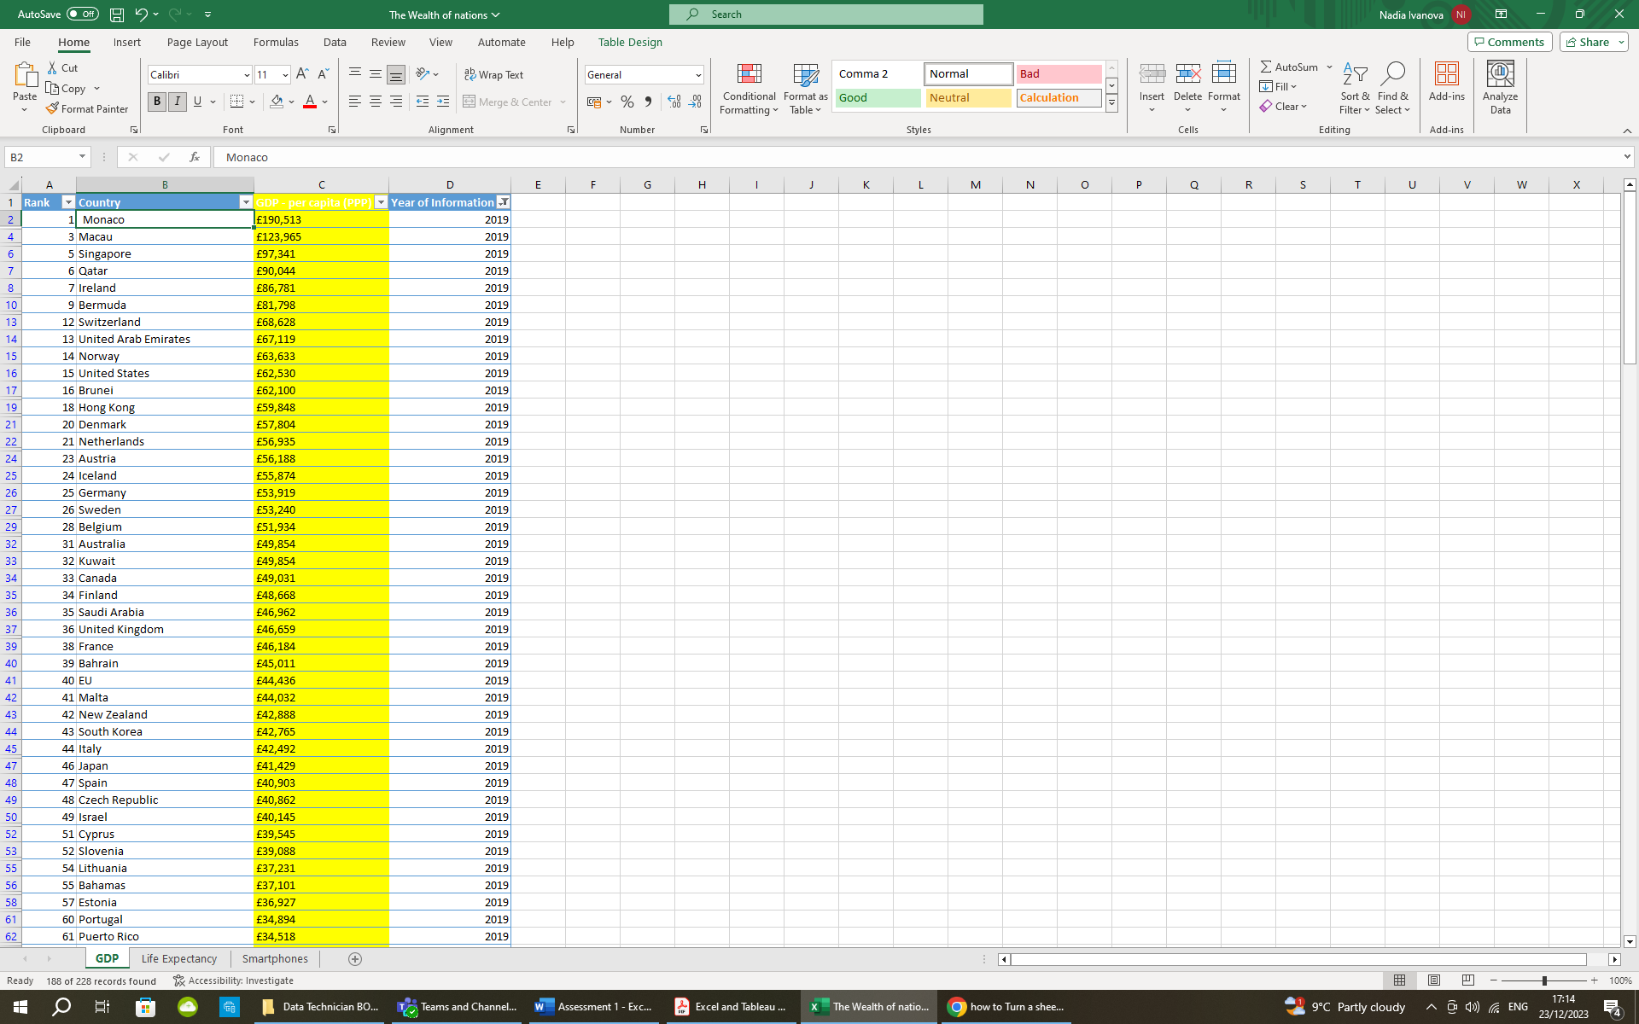Here below is the result:

2

1. Create a chart that will only display the following data ‘Rank, Country and GDP - per capita (PPP).

*Step 1:* Select the data for which a chart is to be created.

*Step 2:* In the INSERT menu select Recommended Charts or any other preferred type of chart. Click OK when done. I would choose Bar chart for this type of data.

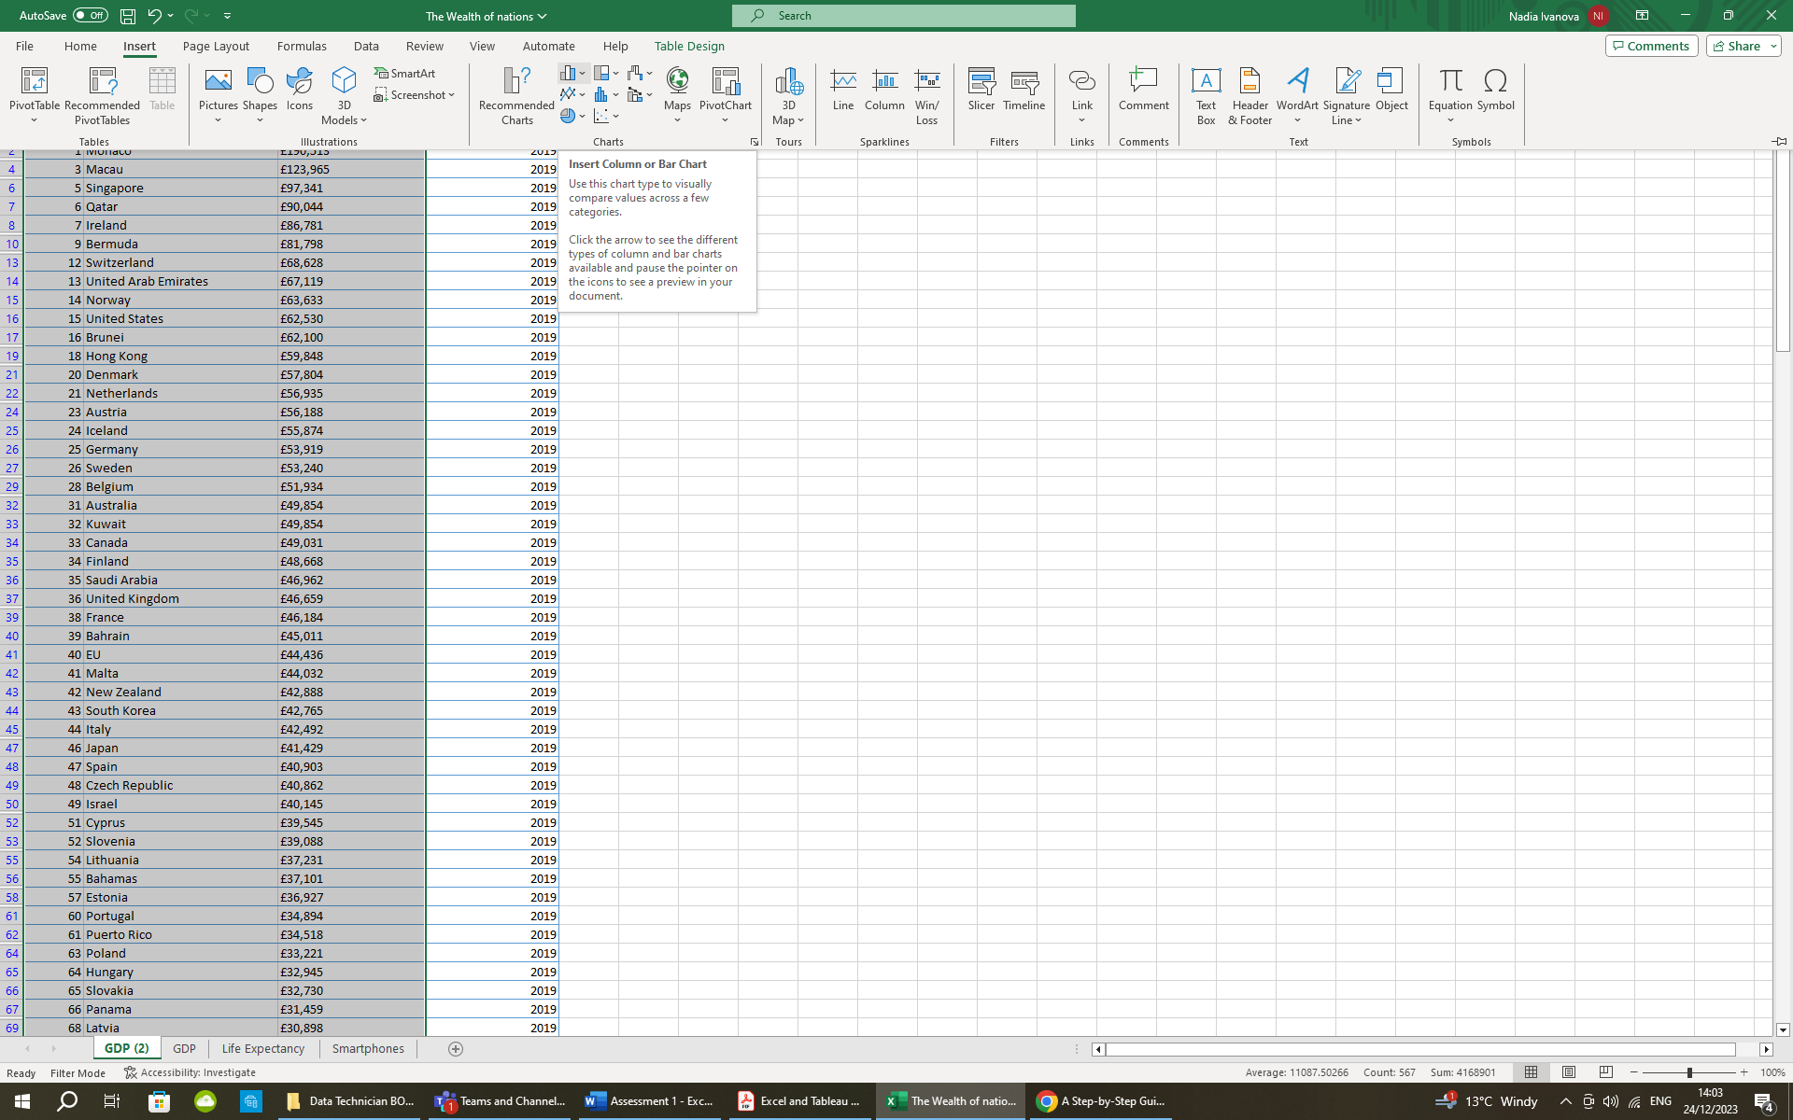

*Step 3:* Here is the created chart, the bottom part of which was cropped in order to fit to this page.



1. Using your creative skills edit the chart

a. Add a title

b. Add X and Y axis labels

c. Make the chart visually pleasing

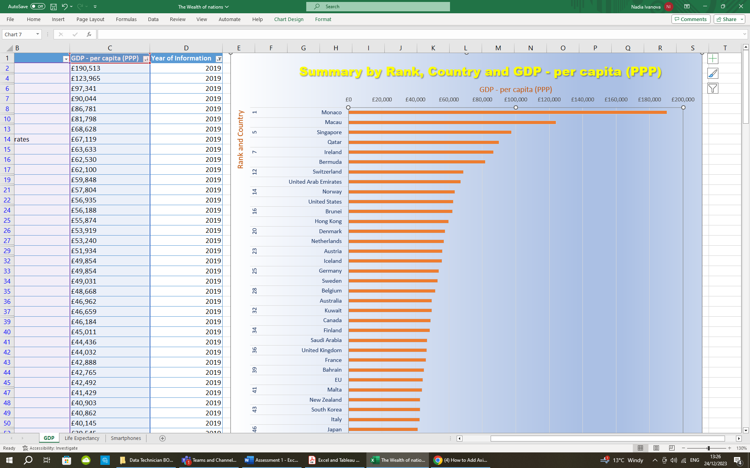

1. Move the chart to a new sheet tab and label with a suitable name

*Step 1:* Select the chart and go to the “Chart design” tab.

*Step 2:* Click on the “Move Chart” icon.

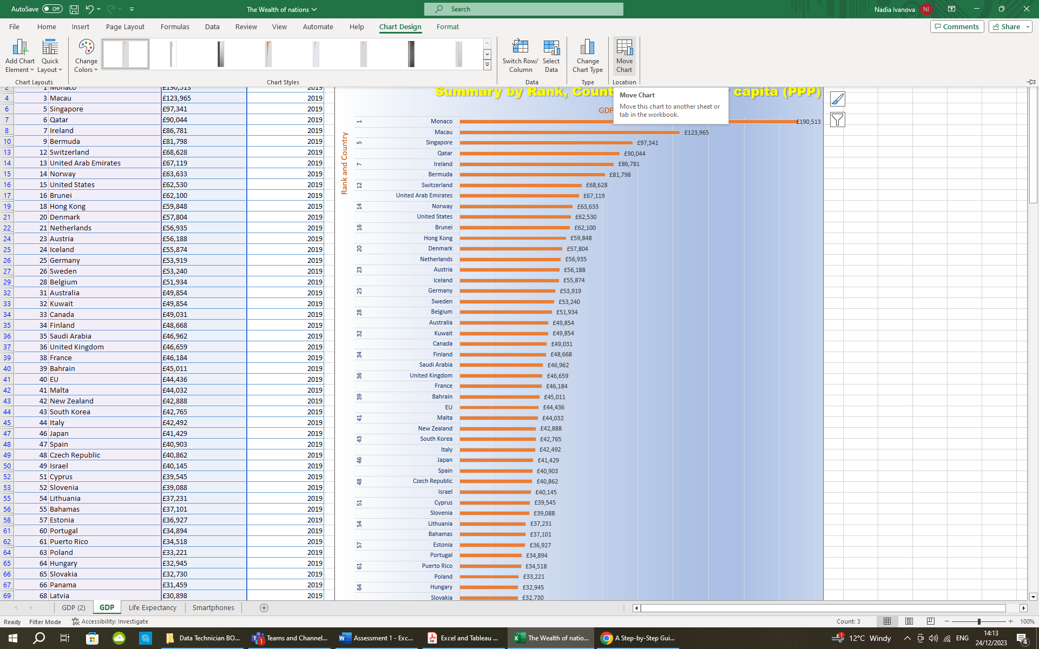

*Step 3:* Select “New sheet:” in the dialog box and give it a suitable name → OK.

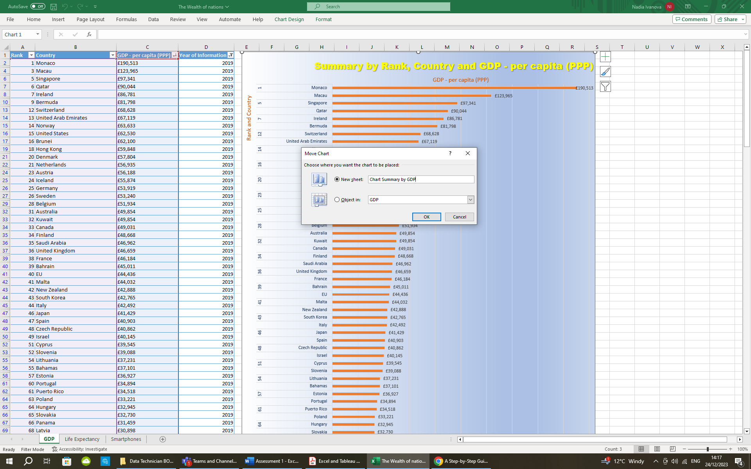

Here is the result:

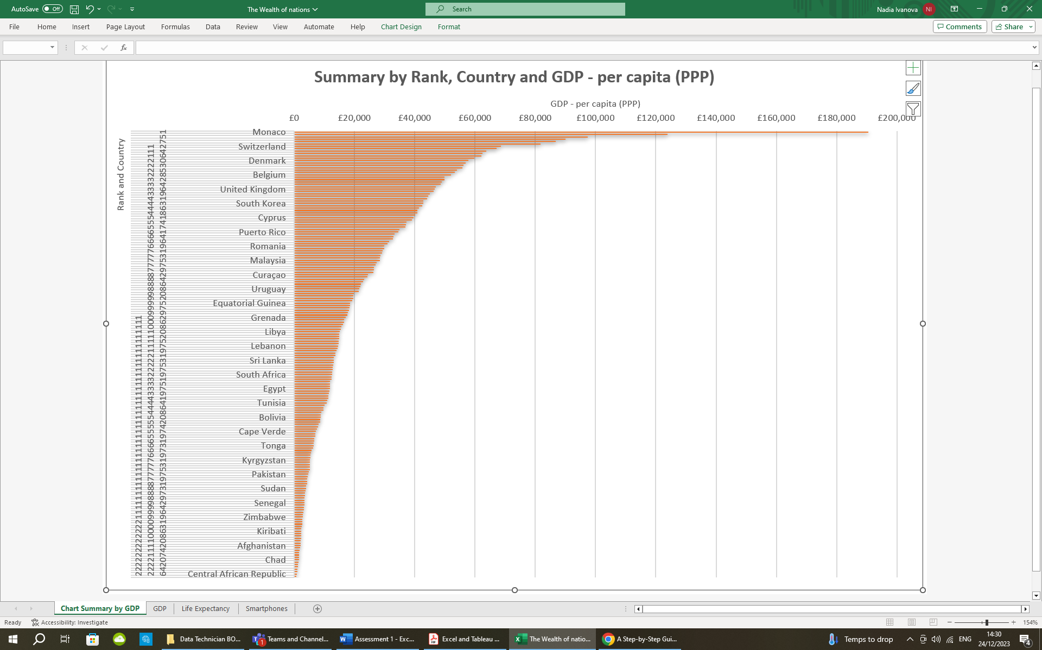

1. Create a sort for the top 20 highest ranking counties

*Step 1:* Go back to GDP worksheet and click on the drop-down menu of the column “GDP – per capita (PPP) (Pointer 1).

*Step 2:* Select “Number Filters…” and choose “Top 10…” option (Pointer 2).

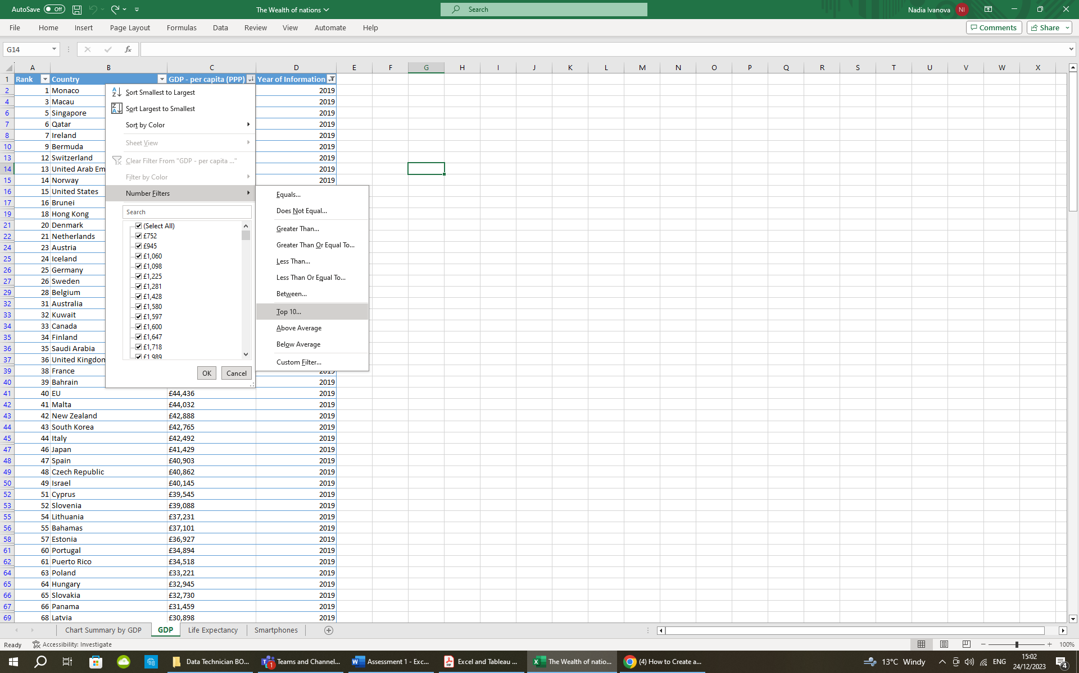

2

1 

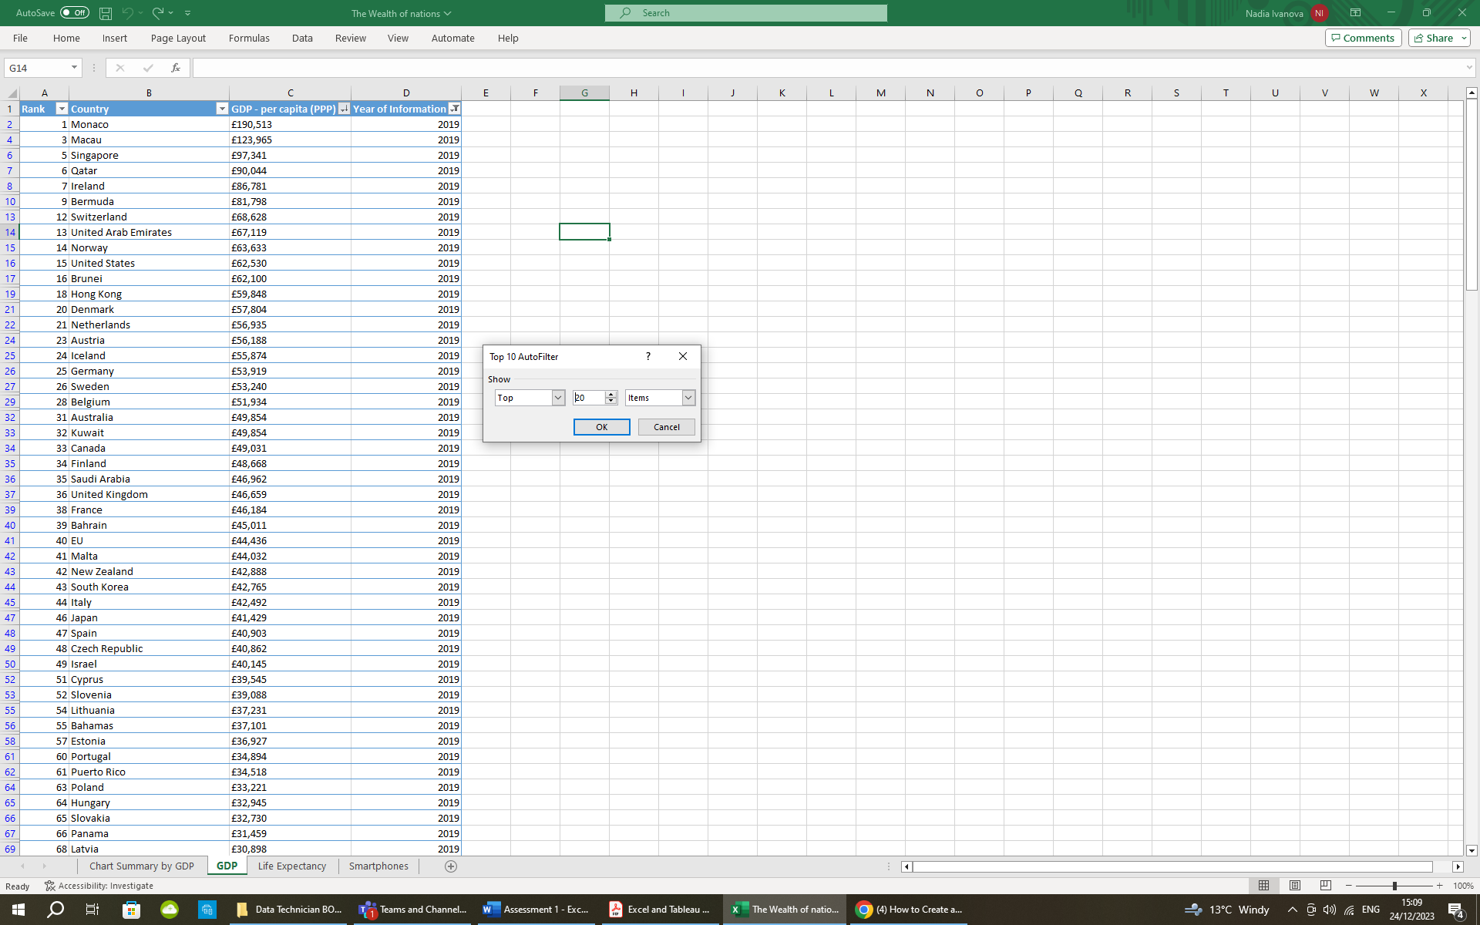

*Step 3:* In the dialog box adjust the number of top items to show in the table – 20 in our case and click OK.

1. Create a new Bar chart to display the 20 highest ranking countries from your sort and then move the chart to be underneath the table.

*Step 1:* From the newly created table select the first three columns (Rank, Country, GDP).

*Step 2:* Click on the appeared icon in the bottom right corner and choose tab “Charts” where you can select the preferred type of chart. In this case I would choose the second option.

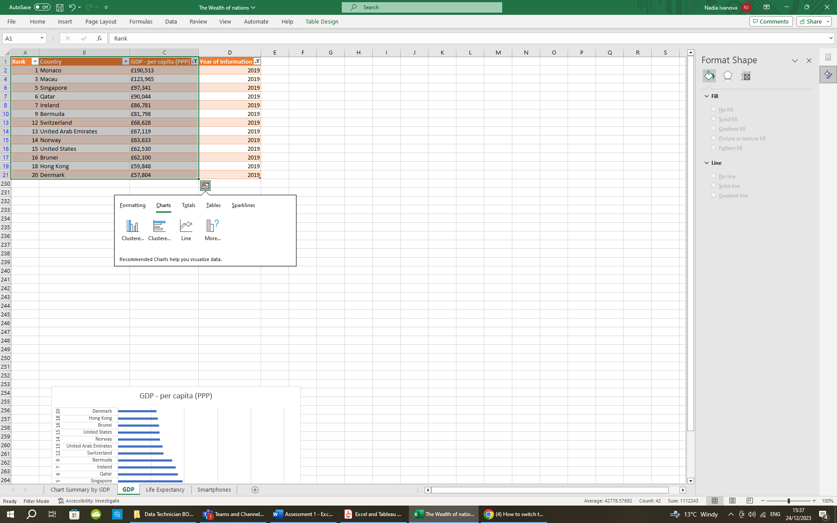

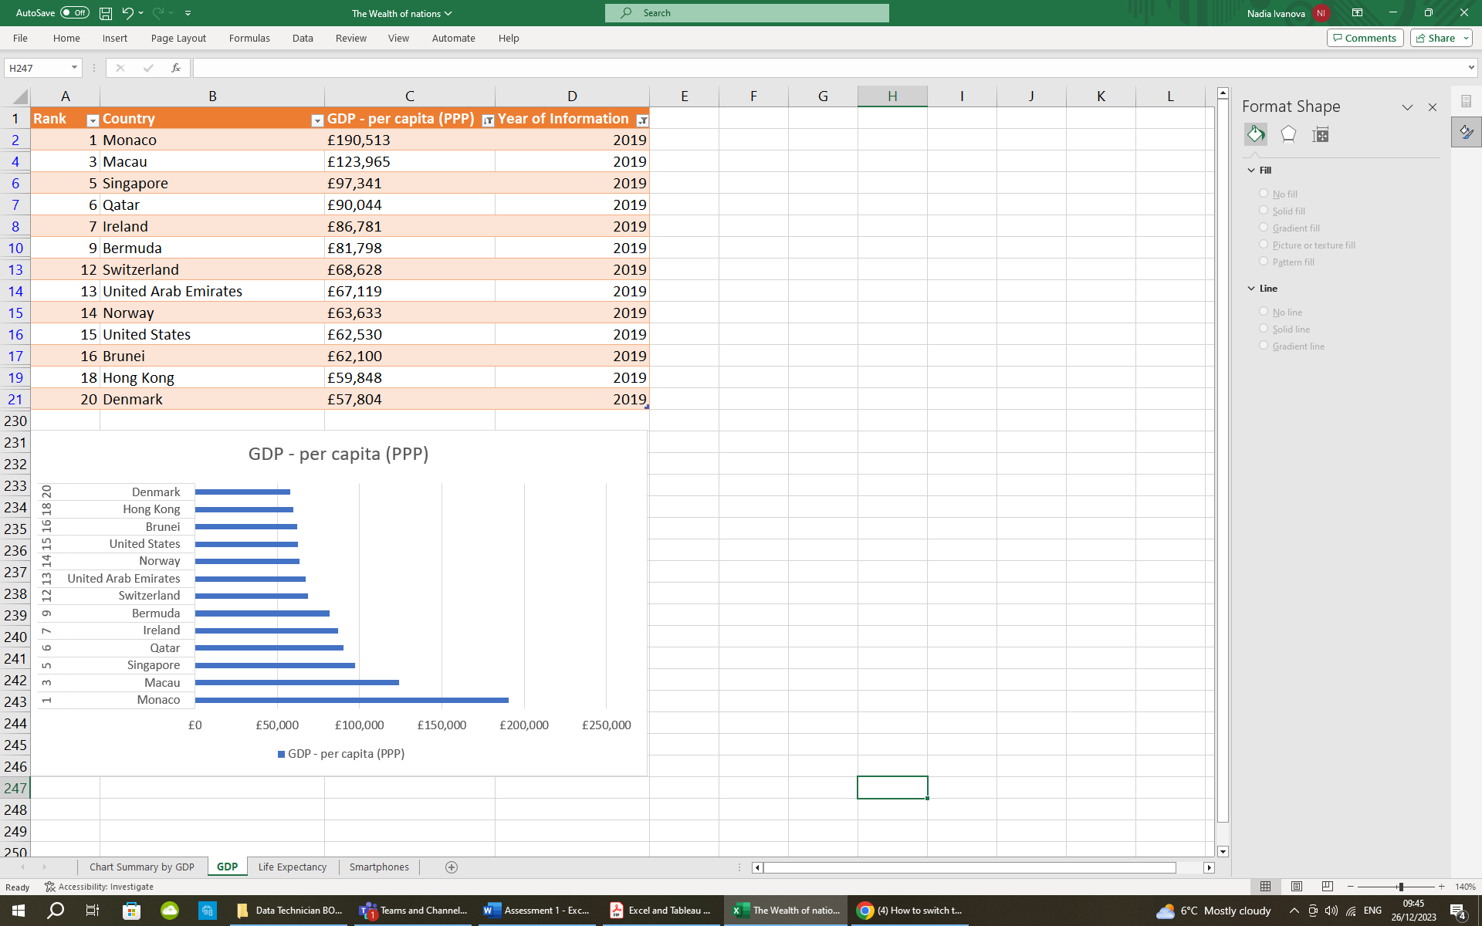

Here on the right is the result:

1. Colour the background by highlighting the area underneath the table as shown below. Find the add a fill colour icon and select a colour.

Here is the result of this task:

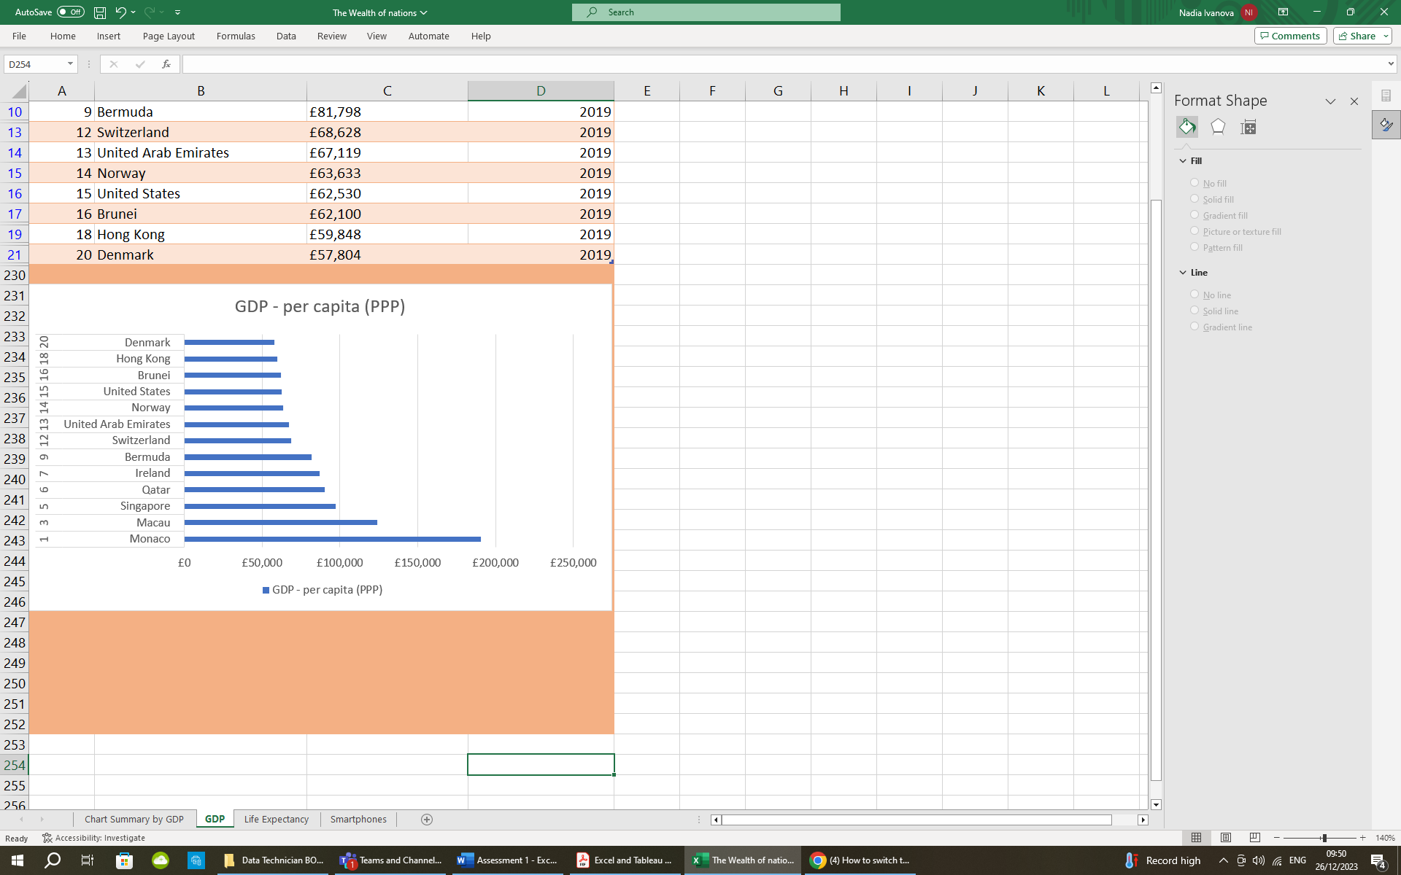

# **Third Task**

## **TABLEAU**

1. Import data

The excel table “Wealth of nations was imported to the Tableau.

1. Set relationships:

Below are the examples of two types of arrangement of the relationships.

1. in straight line:

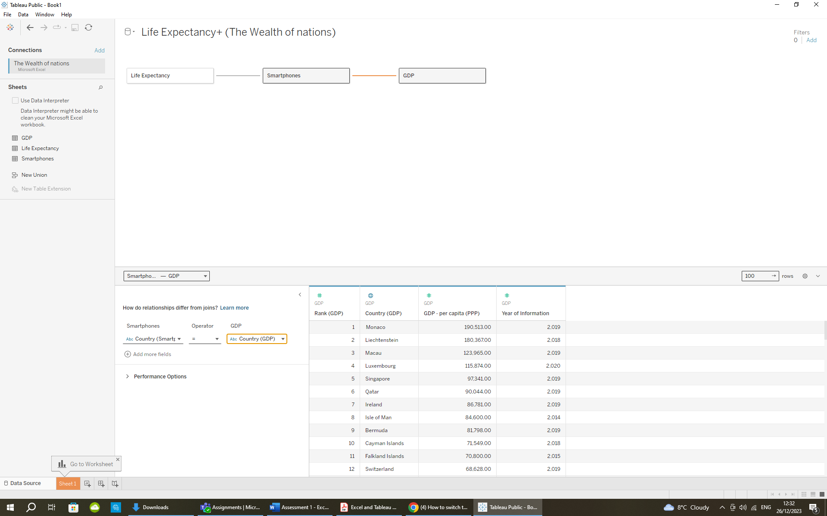

1. Or in this way, which was used for my further work on the project:

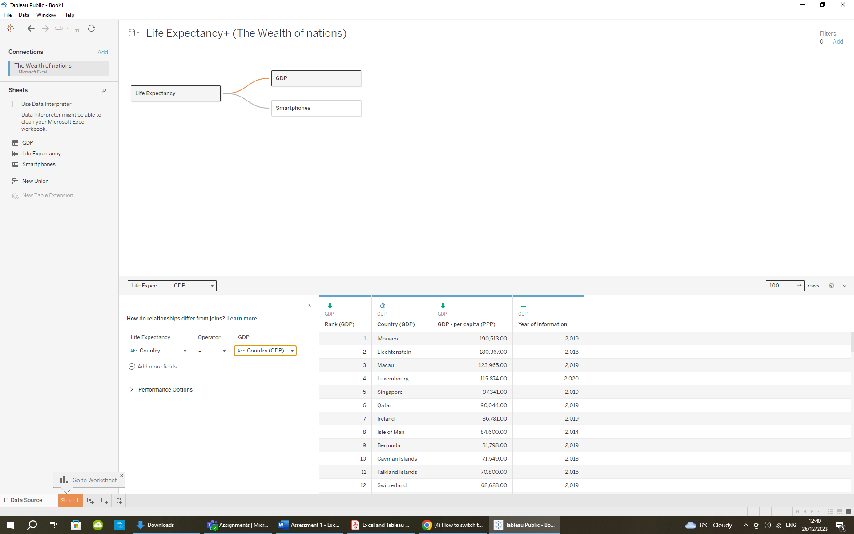

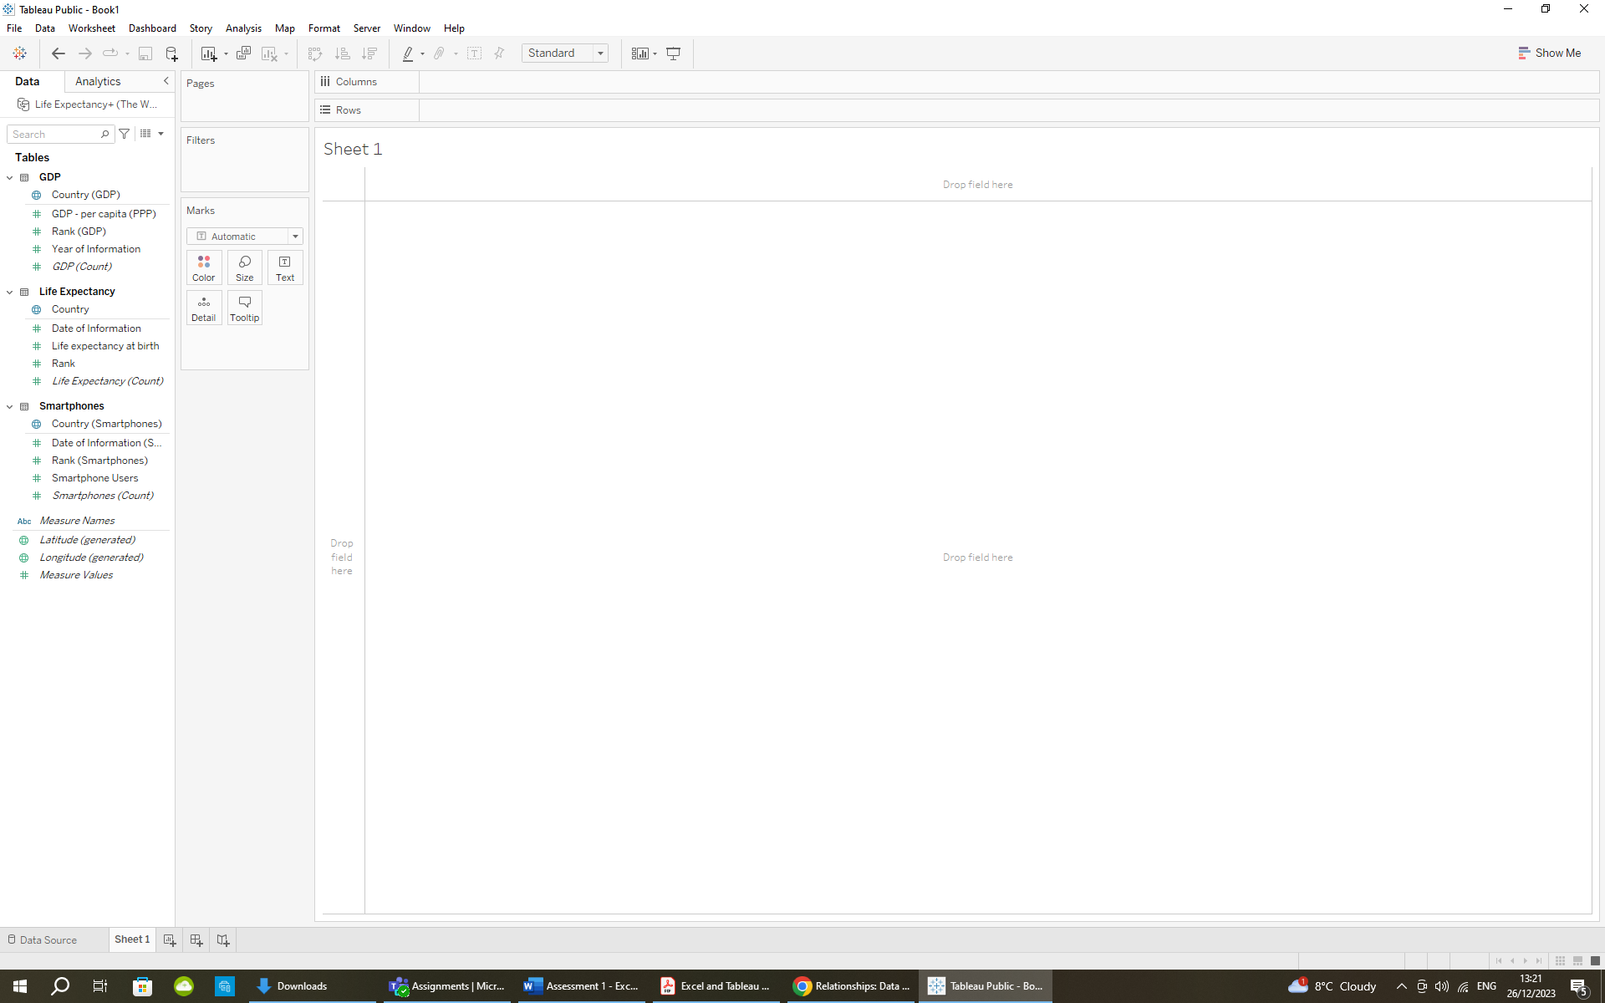

1. Check data types.

To see the data types, we need to go to “Sheet 1”, as shown on the right:

Tableau identifies each field as a *dimension* or *measure* in the Data pane, depending on the type of data the field contains.

*Dimensions* contain qualitative values (such as names, dates, or geographical data). You can use dimensions to categorize, segment, and reveal the details in your data.

*Measures* contain numeric, quantitative values that you can measure. Measures are aggregated by default.

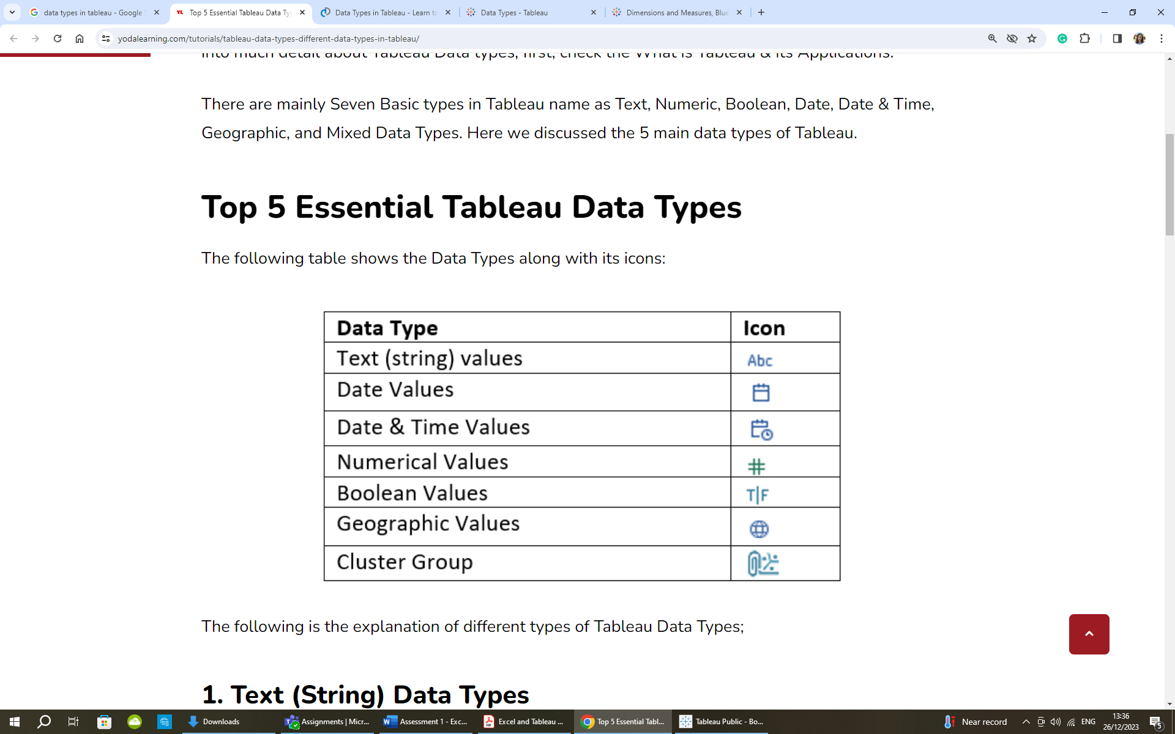

1. Build charts

**Client Requirements**

The client is colour blind and requested to bear this in mind when building the dashboard. The client is only interested in the top 20 highest ranking countries.

Chart 1:

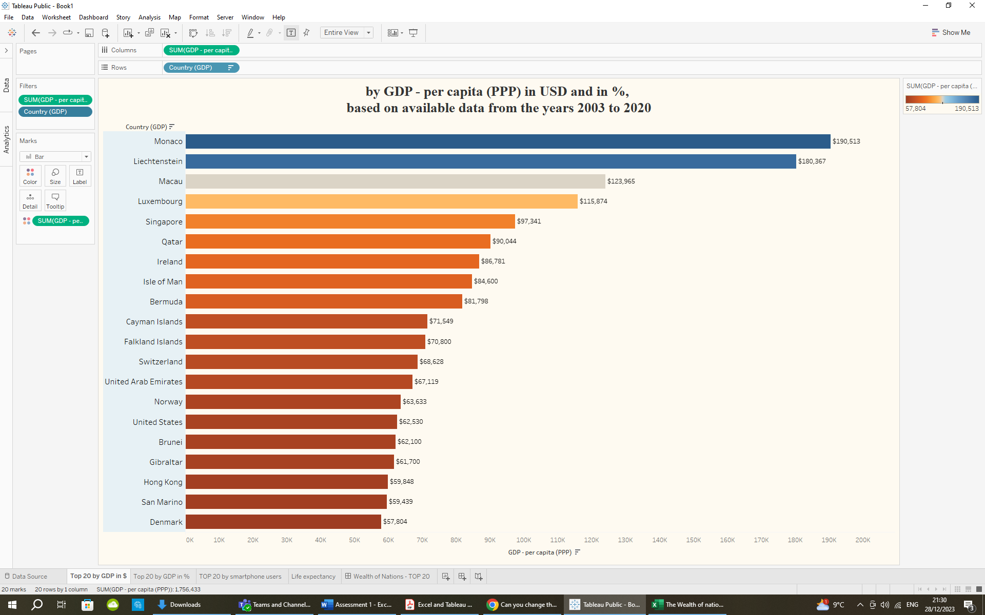

Chart 2:

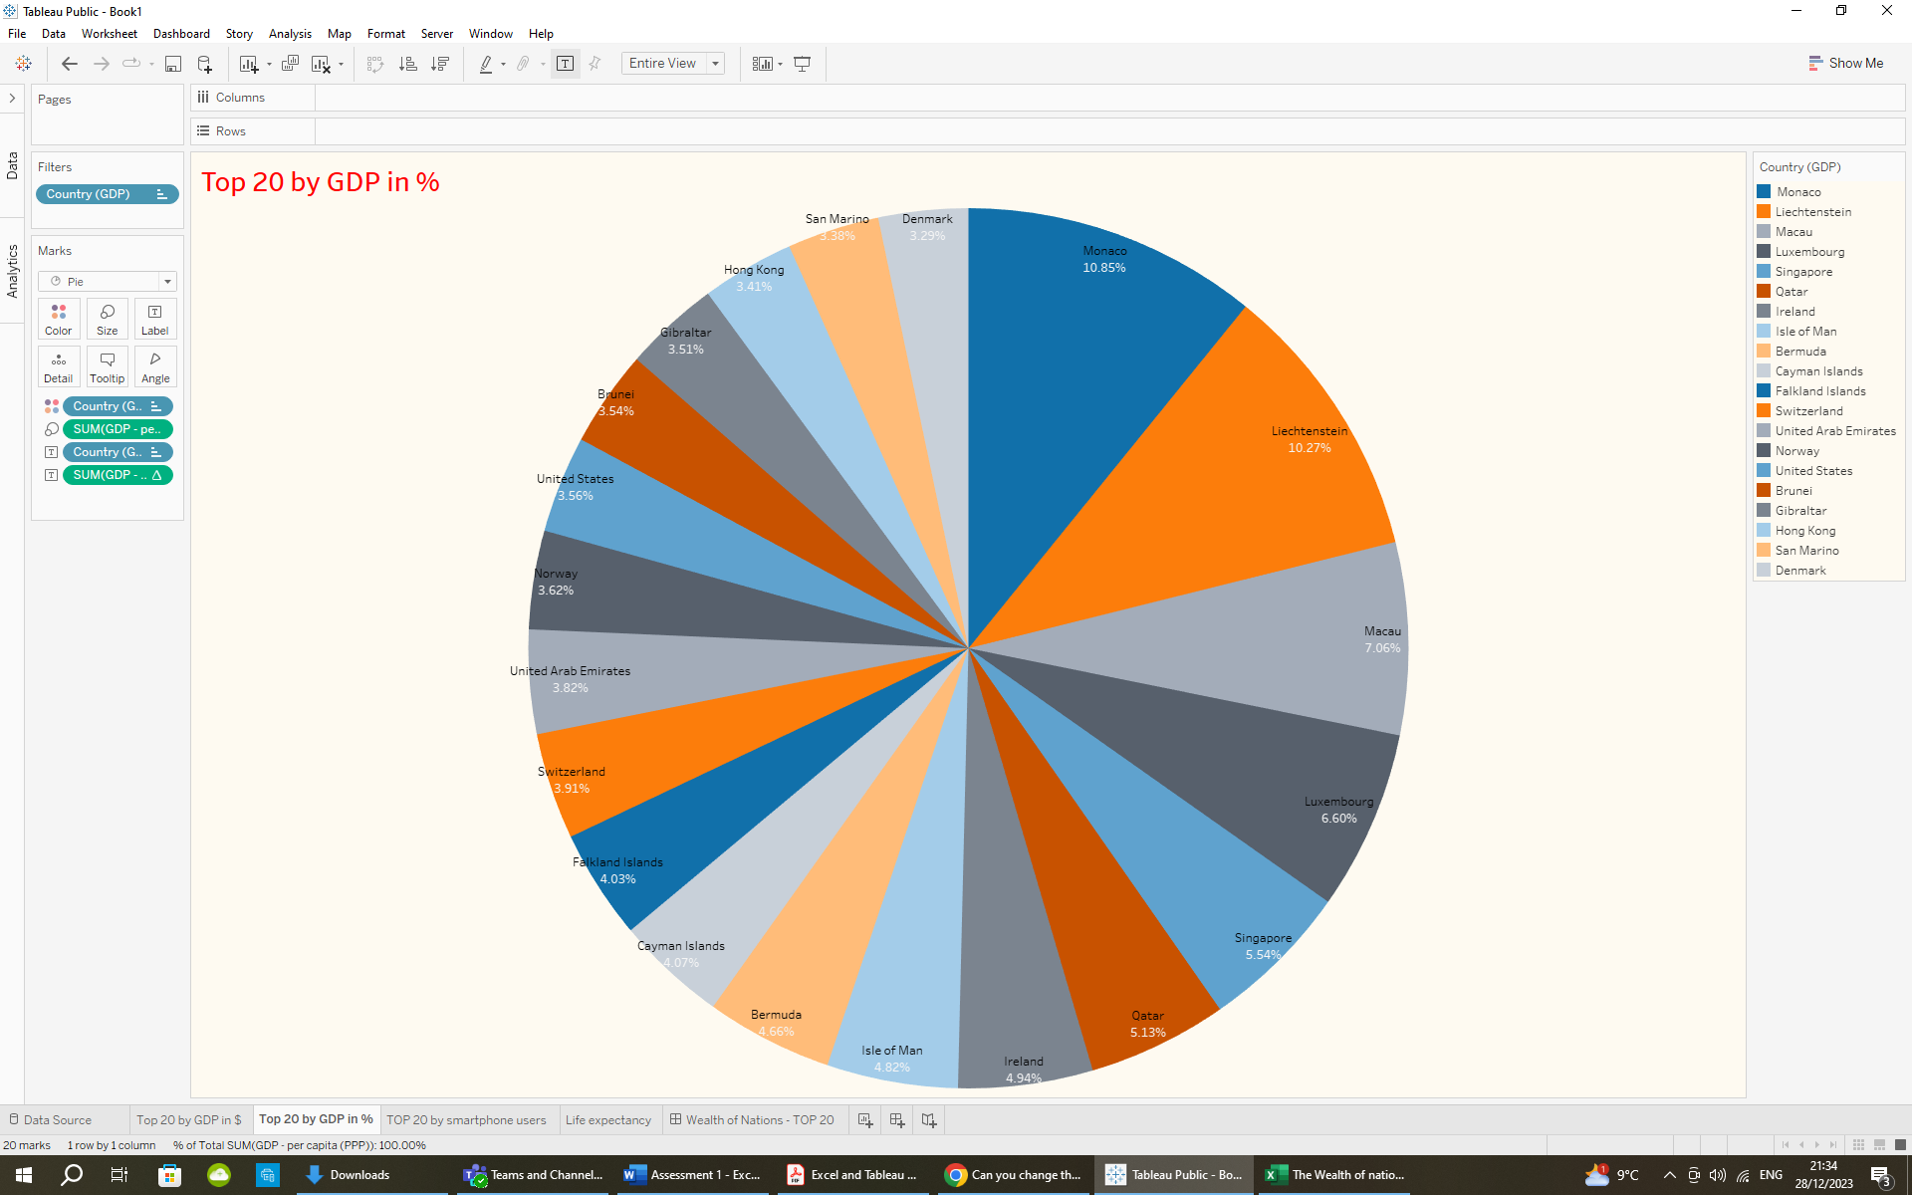

Chart 3:

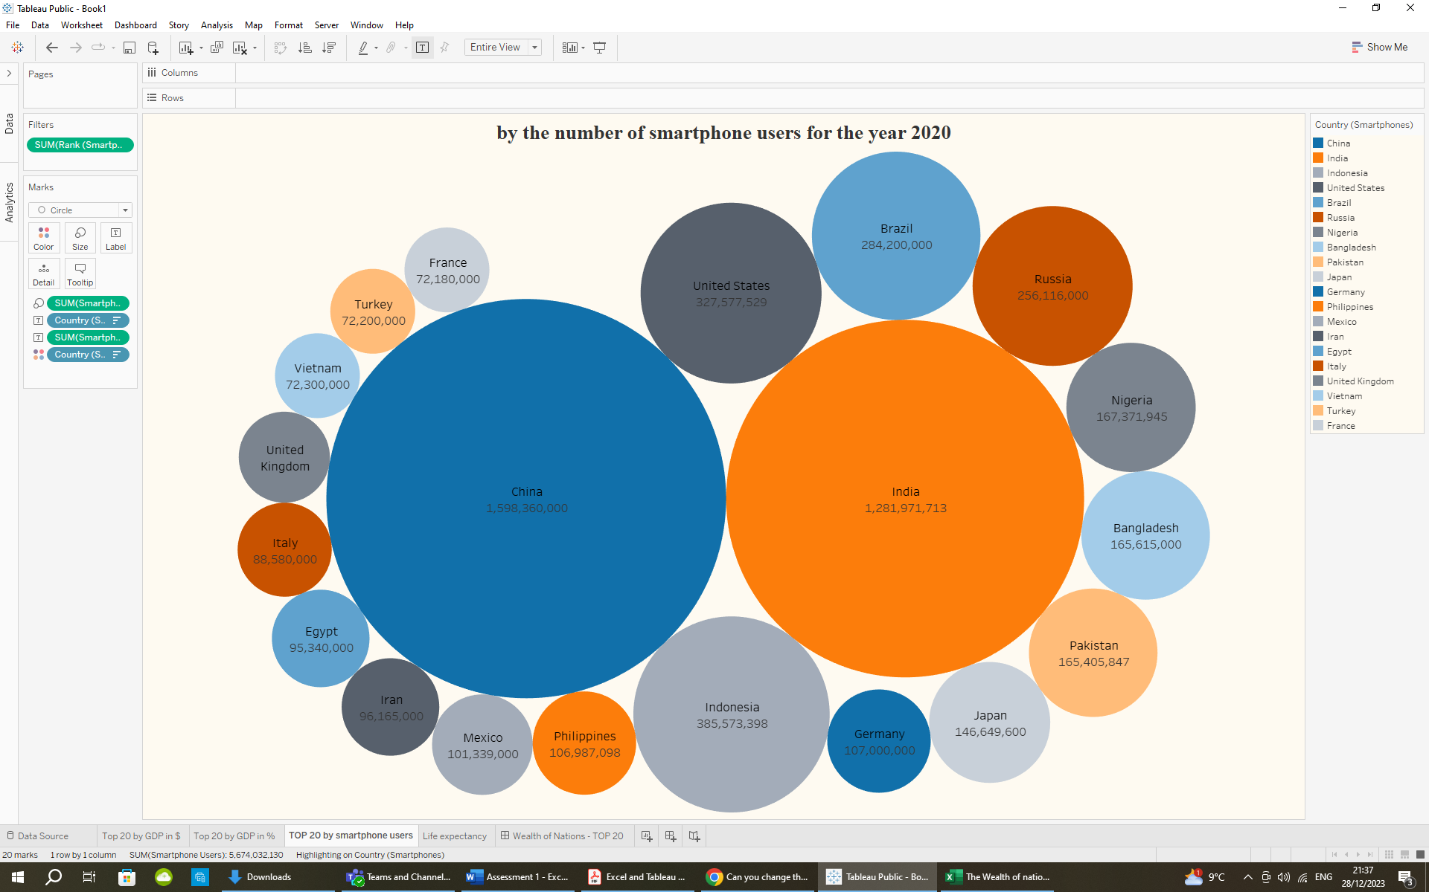

Chart 4:

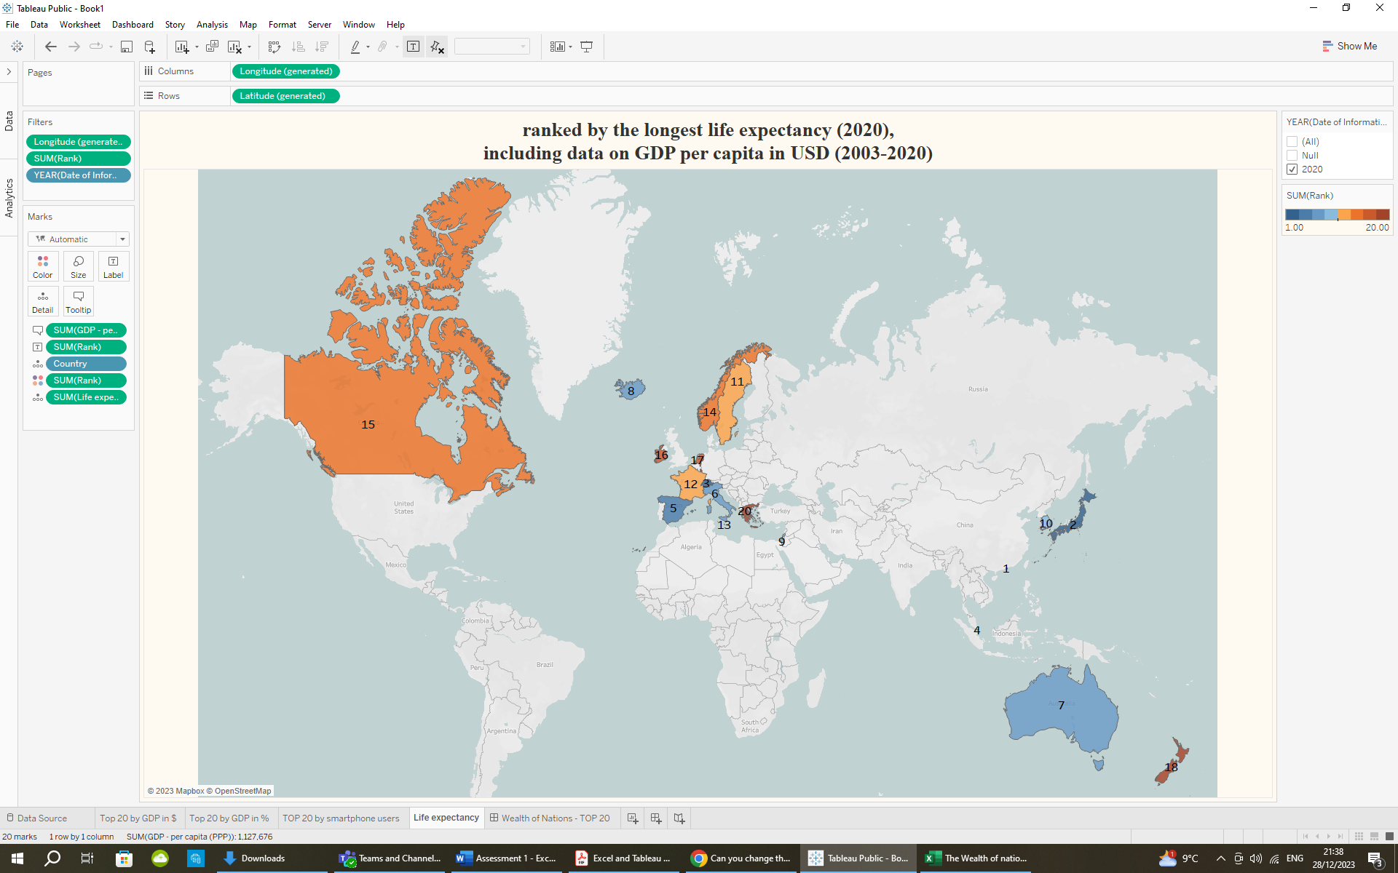

1. Null values

As I created my charts, I removed all null values by selecting the filter option.

1. Build your dashboard

While creating the charts for the dashboard, color-blind-friendly palettes were chosen whenever possible. The dashboard was designed to visualise and highlight a specific set of data from the 'Wealth of Nations' Excel table. The main focus was on showcasing the top 20 countries ranked by several indicators, as illustrated in the visualisation below and published here: https://public.tableau.com/views/WealthofNationsAssignment/WealthofNations-TOP20?:language=en-US&publish=yes&:display_count=n&:origin=viz_share_link

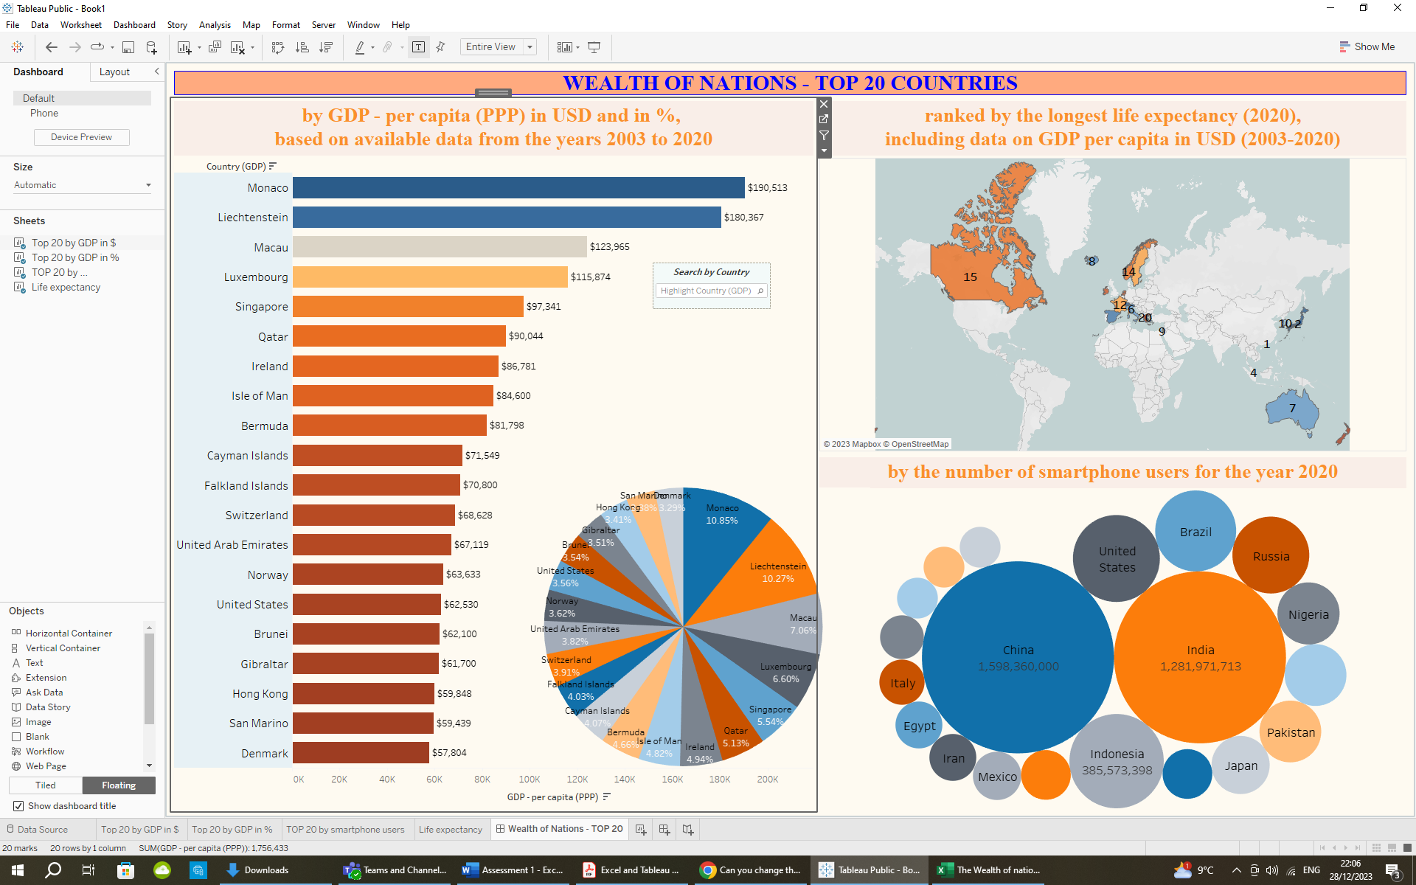

1. The first two charts for the top 20 countries - by GDP in USD and in % (the horizontal bars chart and the pie chart) share the same filter data for the 20 top countries by GDP, which made it possible to introduce a shared “Search by Country/Highlight Country” field on the dashboard. By choosing a country from the dropdown menu you can see the data highlighted for this specific country only. The shown percentage in the pie chart includes the percentage of wealth by GDP for only those top 20 countries, and not for the entire world.

*The insight*: Most of the countries on this list are relatively small in both size and population, with the exception of the USA. In these cases, size plays a crucial role due to several positive factors such as streamlined political and economic management, a focus on specific profitable industries based on geography or natural resources, and investments in high-quality education for the population. For instance, leading countries like Monaco, Liechtenstein, Luxembourg, and others concentrate on providing financial and banking services on a global scale. Typically, these countries are democratic states with well-defined legal systems. The wealth per capita is distributed more proportionally among the population of these countries.

On the other hand, some countries, particularly in the Far East, heavily rely on natural resources like petroleum and oil as their main industries. Although these nations rank high in GDP per capita, wealth distribution is not always equitable, and poverty may persist among a significant portion of the population. These observations highlight the conditional nature of such statistics, making comparisons not always entirely fair.

1. The map visualisation shows the top 20 countries with their rank numbers in descending order by the longest life expectancy (according to data from 2020). When pointing to a chosen country, the info in the tooltip presents not only the country name, but also the years of life expectancy at birth and the GDP per capita in USD data for that particular country. The zoom option for the map is included.

*The insight*: The life expectancy of a nation is influenced by various factors, with one of the primary determinants being the overall quality of life shaped by economic and political conditions. This explains why the countries ranking highest in life expectancy are predominantly democracies with a more equitable distribution of high GDP per capita, indicating well-functioning economic and legal systems. Notably, a significant majority of these nations are located in Europe.

1. The packed bubbles chart presents the top 20 countries by the number of smartphone users according to the data for 2020. As I intentionally did not allow labels to overlap other marks, the full information on the country name and the number of users is visible only for the top 3 countries. The data for the rest of them could be checked when hovering above the respective bubble.

*The insight*: The number of smartphone users in a country is inherently tied to its total population. Naturally, more populated countries tend to have a higher number of smartphone users. In today's world, smartphones have become an essential part of our lives, and their affordability has made them accessible to a vast majority of people worldwide. Consequently, the top 20 countries with the highest number of smartphone users align closely with the countries that rank highest in terms of population.

*The data and charts on this dashboard invite a deeper exploration, providing opportunities for broader insights and interpretations. Anyone willing to delve into more details and showcase analytical expertise can uncover valuable perspectives.*